**A PERSONAL PORTFOLIO-WEBSITE DESIGN REPORT**

**Introduction**

The goal at hand is coming up with a simple portfolio website using basic tools like HTML,CSS, and JavaScript. The following is basic criteria to meet for this project at hand. At the end of this project, the site is expected to clearly show use of these tools in unison leading to the creation of a simple website with personal information. Things to look out for include things like animations and transitions, background & text colours, and easily accessible content on the webpages.

**Overview**

* **Initial specification/webpages**

Whilst creating a personal portfolio website idea, one should ensure that the website has a webpage that have enough levels of interactivity and fun features when a sure interacts with the website. This will in turn to draw the user in as they might try to navigate the site to gather whatever they are after. Interactivity includes things like several webpages linked to one site that one can swap through, animations that are activated with a user’s action for example moving a cursor over a block of text and having it react i.e., fading. Other forms of interactivity would be having buttons on pages from the final website have specific goals e.g., download buttons. To have a good site, one can add smooth transitions to the different webpages to add an extra level fun to the site. Below is an image that shows button n the navigation bar that would lead to different webpages.

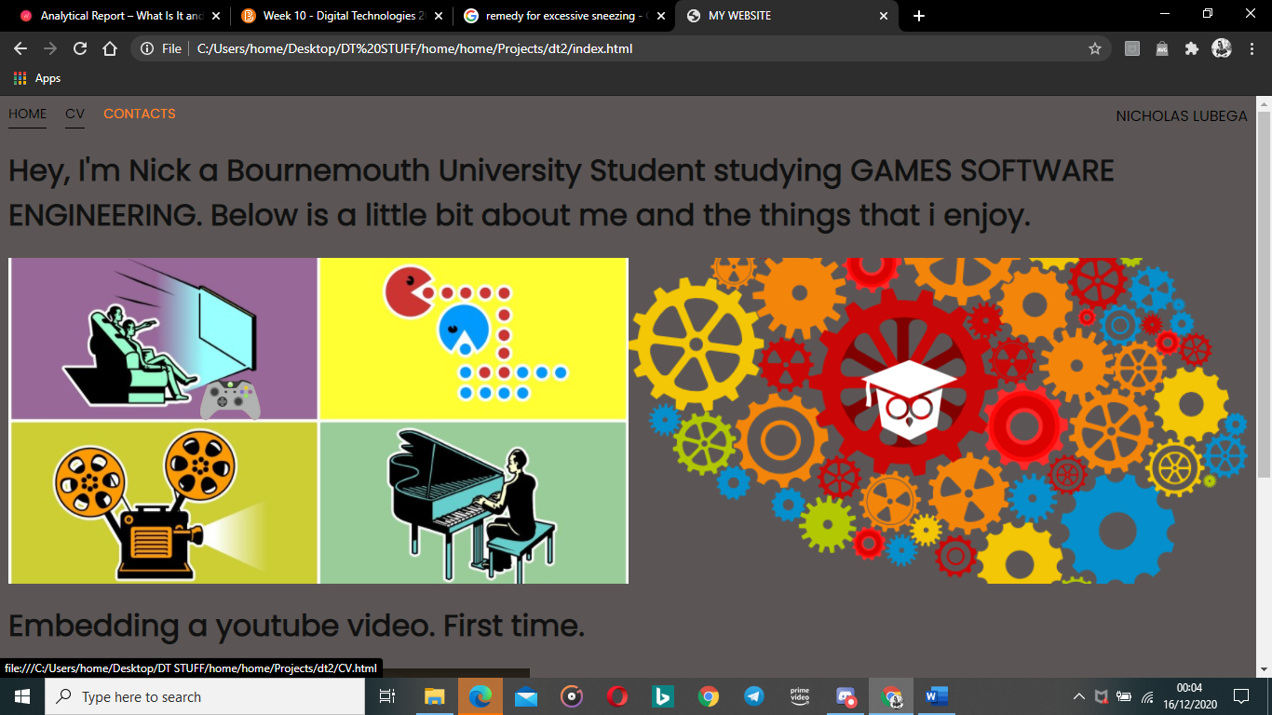

* **Use of pictures on webpages.**

Another main thing to add to this personal portfolio website is pictures because this gives the website more to look at and in turn help draw a user in whilst he or she navigate it. The addition of things like pictures onto the various webpages one might have helps to also make navigation of the website easier for the users to use as they will be able to find information easier as picture tend to be self-explanatory and in this case each image will be linked to a specific piece of information for example having an image of a games console on the webpage will imply that the information displayed is about games or other forms of entertainment. For a personal portfolio website, one would need to also include pictures next to the text content on a webpage that link to things like their hobbies, their personal documents etc. Each web page that would have a picture will be linked to what the text on the body of the page is about. This would add character to the website in general.

**Example of use of images.**

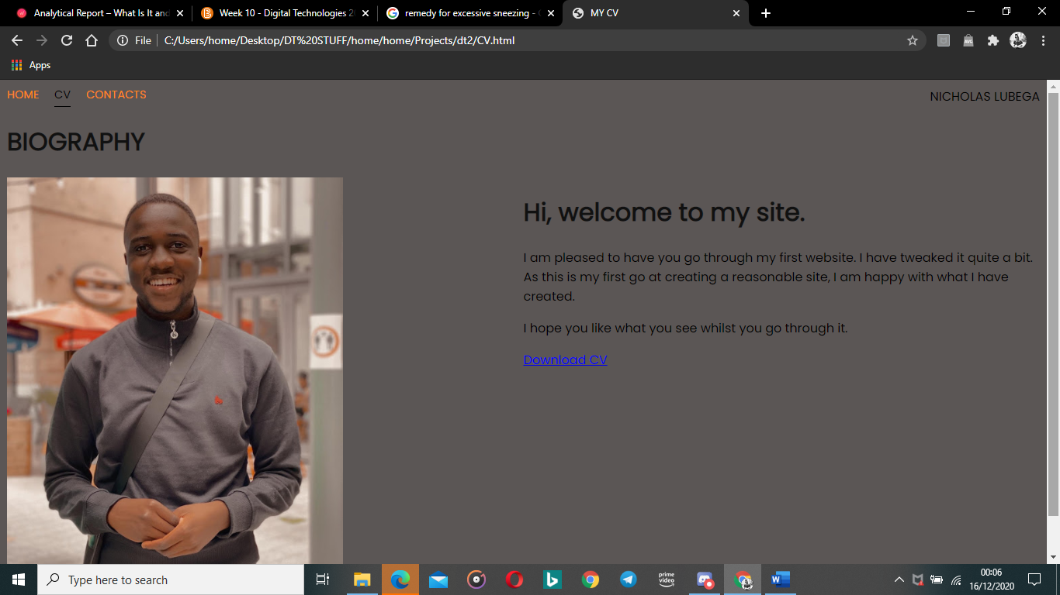

* **Use of external CSS file for design elements.**

For things like colour of the content being displayed on to the website one will have to make sure the website is very clean, professional, and simple and convey their idea as a reality. To do this, and external CSS file is used as it allows the customization of font colours, webpage background colours. When CSS is used along with HTML, you can customise the picture size and all this helps to ensure that the website has more character and a good feel if someone were to navigate it at choice rather than have pages with text only and a blank background.

Below is an example of a webpage that has not been modified using CSS and one that has.

|  |  |
| --- | --- |
| **A blank Webpage** | **A Webpage that has been modified using CSS and HTML.** |
|  |  |

**Design for the portfolio site.**

As for the website design, the idea is simplistic and straight forward and here are the 3 pages. the images below will show the website design and how each page will be structured.

* Homepage

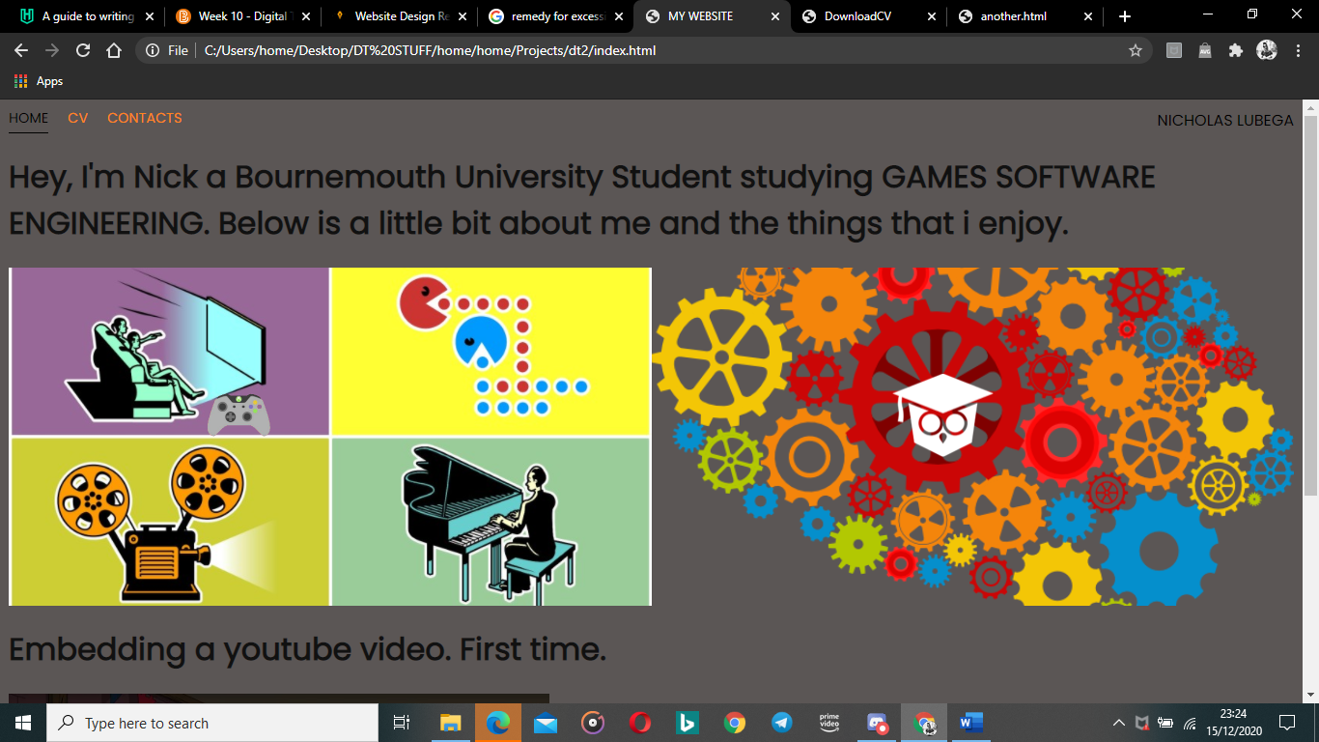

This is the homepage and at the header/ navigation bar are 3 buttons that will take a visitor to the different pages/sections available on the site. On top right-hand side of the header of the website is a name whose information is being displayed on this website.

* CV page

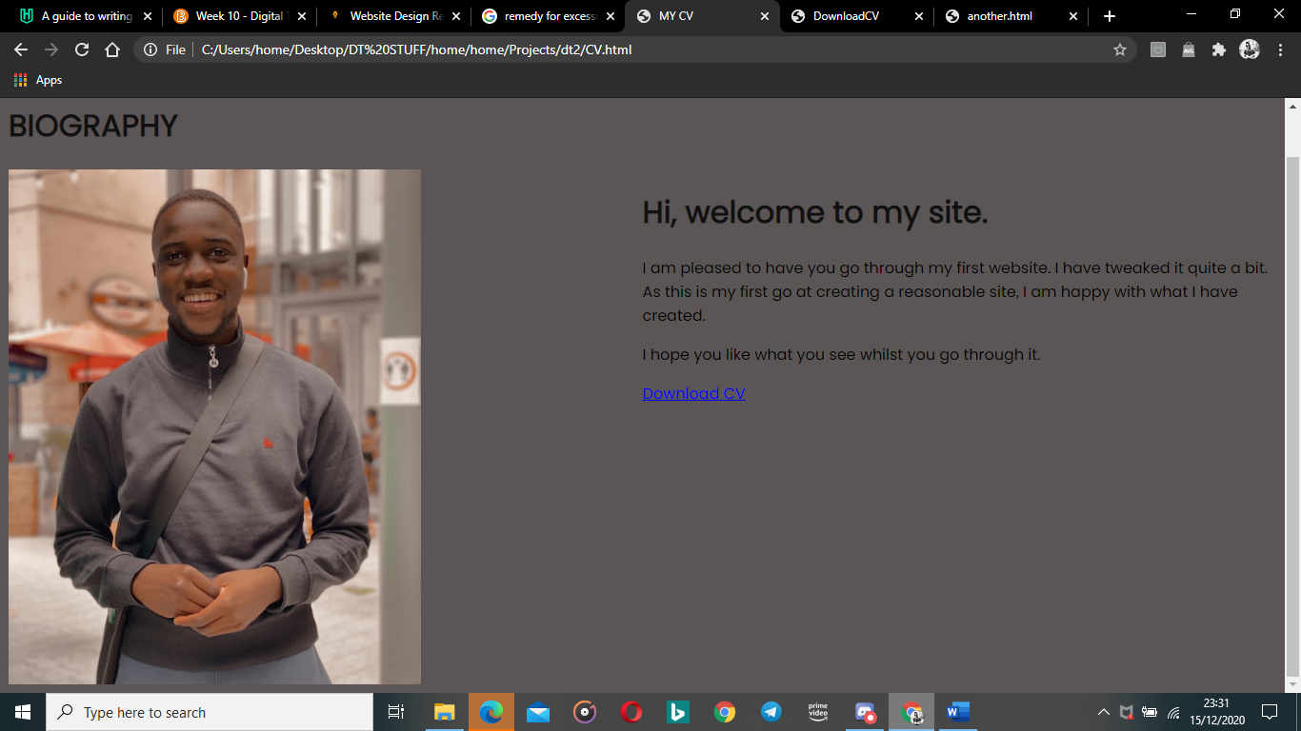

This is the CV page that is meant to be home to the CV (download button) and any other personal information. The gird layout is consistent throughout all the pages just as the home page with the navigation bar/header on the top of the page. In this page there will be a brief description explaining the page.

* Contacts page

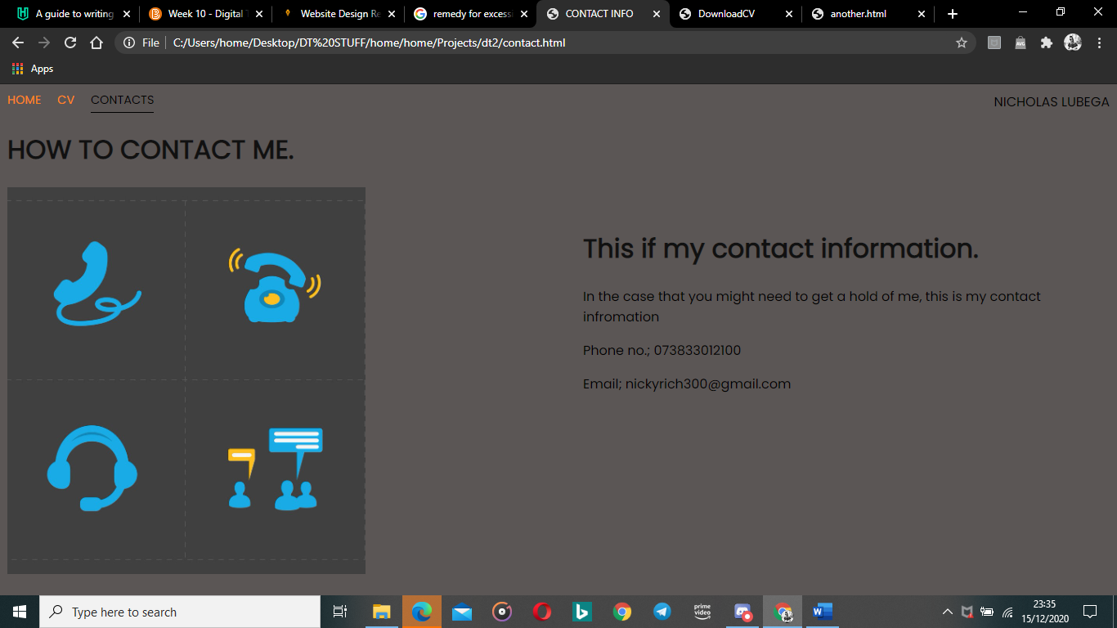

This is the contacts page that is home to the contact information i.e., email, phone number and any other social media form. As seen above the grid layout of the page is consistent with the other pages giving it an organised look. This page has a brief description explaining the page and its content. As you can see in the screenshot there will be 3 buttons on the navigation bar to allow the visitor to navigate freely through each page.

**Conclusion & Analysis of portfolio website.**

Overall, the website meets the simplistic design and ideas one would be after. This is because everything that is allocated onto either of the webpages is explained in further detail and so any visitor would not have trouble navigating the site. Addition of fun interesting features such as hover animations on to the website (i.e., Home page) makes the website fun to navigate and interesting to get to see what the next pages are about. The site clearly shows the use of tools like HTML, CSS, and JavaScript together to come up with a decent and simple yet eye-catching website. Whilst navigating the websites pages, you can tell that the creator focussed on having a final website idea that is to eye-catching, colourful, recognisable, and simple and to display the various content of choice with good use of CSS for the colours and positions of images and text.

All in all, the main aim was to have a better understanding of how to use tools like HTML CSS and JavaScript to come up with a fun website that can be accessed by visitors to navigate and enjoy the experience.